

Project Interim Report

On

File Compression Simulator (Using Core Java & OOP Concepts)
RU-100-01-00012
Object Oriented Programming with Java

SESSION: 2025-26

Submitted By: Ridhima Singh
ERP – RU-25-11163

Bachelor of Technology in Computer Science &
Engineering in association with Google

Under the Guidance of Mr. Ashish Shivhare

SCHOOL OF COMPUTER SCIENCE AND ENGINEERING RUNGTA INTERNATIONAL SKILLS UNIVERSITY
BHILAI, CG

(April 2026)

Abstract
An ‘Employee Payroll Management System’ designed using Object-Oriented Programming (OOP) methods is being developed in this project. This project simulates real-life payroll processes by constructing a defined Employee class hierarchy, which defines the common information (name, ID, salary details) across all employees. The ‘FullTimeEmployee’ and ‘PartTimeEmployee’ subclasses extend the base ‘Employee’ class, adding their own methods for computing an employee's salary via method overriding to illustrate the concepts of polymorphism and inheritance.

Organizations need the use of a payroll management system to more effectively, accurately and in a scalable way manage their employees' wages. Traditional payroll processing is a time-consuming process fraught with errors due to the multi-dimensional nature of the many forms of employees and payment types. The objective of this project is to provide organizations with an efficient, effective, and automatable process for managing their payroll.

The primary functions performed by this system include storing employee information, computing employee salaries according to their employment status type, and supporting the proper construction of the objects through constructor chaining and use of the ‘super’ keyword. The design was made conveniently flexible and extendable, such that organizational management can easily add new types of employees. Ultimately, this demonstrates how to apply OOP concepts in a practical way to create a manageable software product.

Introduction
This system is produces the salary of each employee using OOP concepts with a well-formed hierarchy of classes as follows. The base class being the Employee class that contains attributes such as Employee ID number, Employee Name, and Base Salary information. Then there are subclasses that extend from Employee such as FullTimeEmployee and PartTimeEmployee. Each subclass has its own method to calculate Salary, so therefore uses method overriding and polymorphism in its implementation.

In this project, we are using Constructor Chaining to create a new Employee object (result of calling superclass constructor with keyword "super") during construction of all employees so that every Employee object is properly constructed with its attributes.

The reason behind developing an employee payroll management system is to help eliminate the complexity and mistakes involved when managing payroll manually, especially in large organizations with different levels of employees and their unique pay structure. By implementing this software solution, we have developed a systematic, automated way to process employee's payroll resulting in improved accuracy, consistency, and overall efficiency.

Some of the objectives of this project are: to create and manage employee records; calculate salaries for each employee, based on type of employment; support multiple categories/types of employees; using inheritance to reuse common code; and facilitate the implementation of future enhancements into this system (i.e. additional payment calculations such as bonuses, deductions and/or taxes).

Other features of this project include modularity, clear separation of responsibilities, and the ability to add enhanced functionality in future releases.

Scope
This project is suitable for small libraries and can be extended with database integration in future.

System Requirements
Hardware: Computer with 4GB RAM
Software: Java JDK, IDE (VS Code/Eclipse/Edit Plus)

Methodology
- The system starts by adding employee details such as name, ID, and salary information.

- Employee records are stored as objects using appropriate classes.

- The system provides a feature to search employees using their ID.

- It performs salary calculation based on employee type using polymorphism:
  - Full-Time → Base Salary + Bonus
  - Part-Time → Hours Worked × Hourly Rate

- Users can modify employee details like salary, bonus, or working hours.

- The system may also allow deleting employee records when required.

- It displays employee details along with calculated salary.

- The main method controls all operations, including adding, searching, updating, and displaying data.

Flowchart
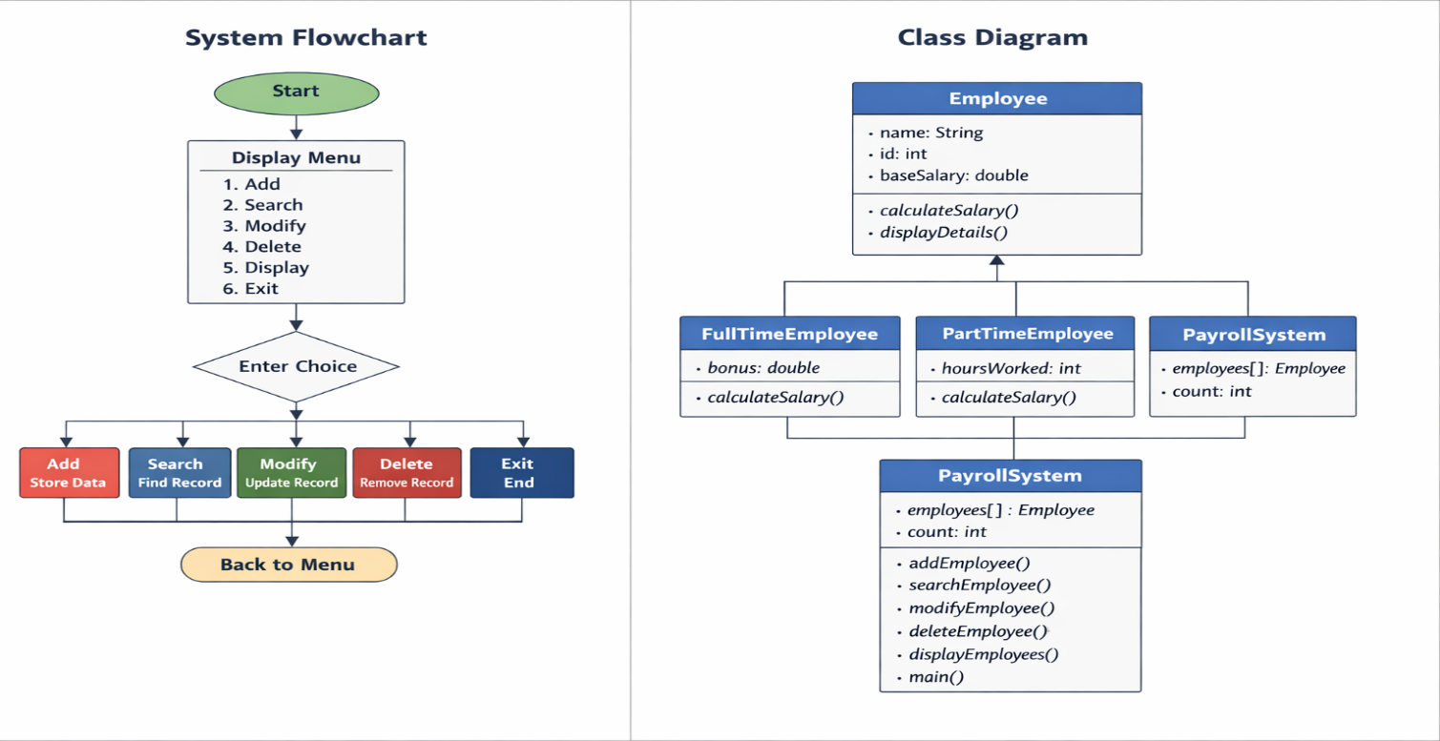

Implementation

Employee Class (Base Class)
- Acts as the parent class for all employees.
- Stores common data like name, ID, and base salary.
- Provides a general method for salary calculation (to be overridden).
- Includes a method to display employee details.

FullTimeEmployee Class (Derived Class)
- Inherits from the Employee class.
- Adds an extra attribute for bonus.
- Overrides the salary calculation method.
- Calculates salary as: Base Salary + Bonus.

PartTimeEmployee Class (Derived Class)
- Inherits from the Employee class.
- Stores hours worked and hourly rate.
- Overrides the salary calculation method.
- Calculates salary as: Hours Worked × Hourly Rate.

PayrollSystem Class (Main Class)
- Manages all employee operations.
- Stores employee objects using an array.
- Provides functionalities like add, search, modify, delete, and display.
- Controls the program using a menu-driven approach.

Sample Input :
Enter Type: FullTime
Name: Riya
ID: 101
Base Salary: 40000
Bonus: 5000
Enter Type: PartTime
Name: Aman
ID: 102
Hours Worked: 40
Hourly Rate: 200

5 (Display Employees)

Sample Output:
Employee Details:

Name: Riya
ID: 101
Salary: 45000

Name: Aman
ID: 102
Salary: 8000

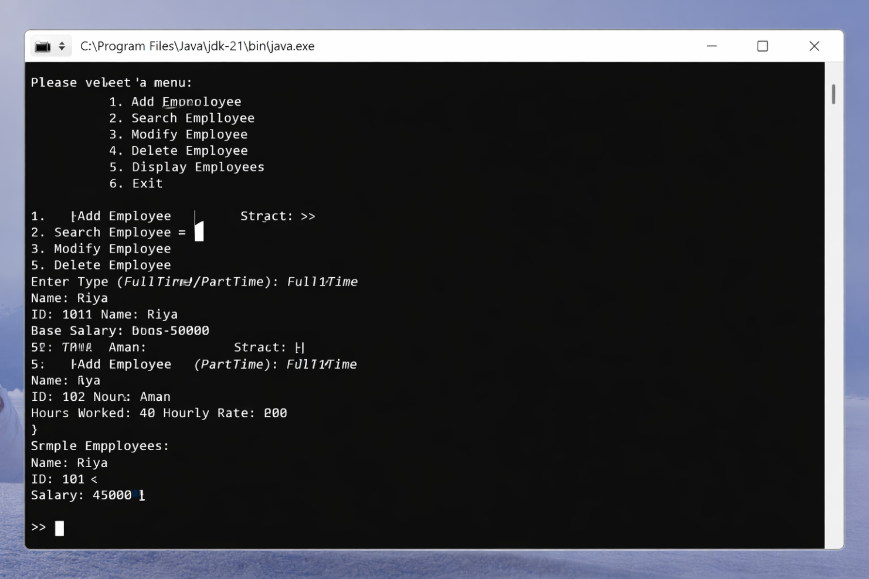

Future enhancements include adding a graphical user interface (GUI) for better user experience, integrating a database for permanent data storage, implementing login authentication for security, supporting more employee types, generating automated salary reports and payslips, and improving error handling, validation, and performance for handling large-scale employee data efficiently.

Gantt Chart
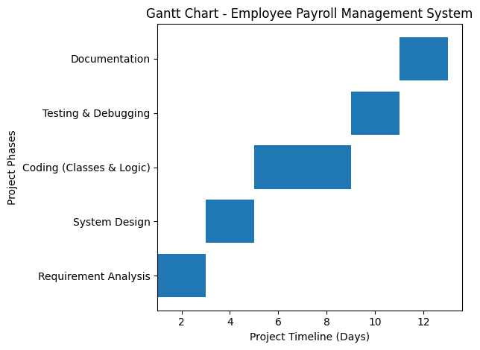

Conclusion

The project successfully demonstrates Java OOP concepts and provides a functional system.

References

Book
[1] H. Schildt, *Java: The Complete Reference*, 11th ed. New York: McGraw-Hill, 2018.

[2] Y. Daniel Liang, Introduction to Java Programming and Data Structures, 12th ed. Boston: Pearson, 2020.

[3] J. Bloch, Effective Java, 3rd ed. Boston: Addison-Wesley, 2018.

Website
[1] Oracle, "Java Documentation," Oracle. [Online]. Available: https://docs.oracle.com

[2] GeeksforGeeks, "Java OOP Concepts," GeeksforGeeks. [Online]. Available: https://www.geeksforgeeks.org

Conference Paper

[1] S. Kumar, "Payroll Management System Design," in Proc. National Conf. on Software Engineering, 2019, pp. 45-50.
Journal Article

[1] A. Sharma and R. Gupta, "Object-Oriented Design in Software Systems," International Journal of Computer Science, vol. 5, no. 2, pp. 45-50, 2020.

